Lab6: ROS2 Perception – Line Follower

- How to use OpenCV in ROS2
- How to follow a line
- How to find different elements based on color
- Track multiple paths and decide
- Create a basic PID for the line following

OpenCV is the most extensive and complete library for image recognition. With it, you can work with images like never before: applying filters, post-processing, and working with images in any way you want. OpenCV is not a ROS2 library, but it's been integrated nicely into ROS with http://wiki.ros.org/cv_bridge. This package allows the ROS imaging topics to use the OpenCV image variable format.
For example, OpenCV images come in BGR image format, while regular ROS images are in the more standard RGB encoding. OpenCV_bridge provides a nice feature to convert between them. Also, there are many other functions to transfer images to OpenCV variables transparently.
If gazebo is stuck use the following command
killall -9 gzserver
sudo apt install libopencv-dev python3-opencv

cd ros2_ws/src
ros2 pkg create lab6 --build-type ament_python --dependencies rclpy std_msgs
cd ..
colcon build
open lab6 with visual studio application
create urdf folder
create a file car.urdf inside the urdf folder

Create a launch folder
Create a launch file rviz.launch.py

import os
from ament_index_python.packages import get_package_share_directory
from launch import LaunchDescription
from launch_ros.actions import Node

def generate_launch_description():
package_dir = '/home/asha/ros2_ws/src/lab6/urdf'
urdf = os.path.join(package_dir,'car.urdf')

return LaunchDescription([
Node(
package='robot_state_publisher',
executable='robot_state_publisher',
name='robot_state_publisher',
output='screen',
arguments=[urdf]),

Create a launch folder
Create a launch file gazebo.launch.py inside the launch folder

import os
from ament_index_python.packages import get_package_share_directory
from launch import LaunchDescription
from launch.actions import DeclareLaunchArgument, ExecuteProcess
from launch.substitutions import LaunchConfiguration
from launch_ros.actions import Node
from launch.launch_description_sources import PythonLaunchDescriptionSource

def generate_launch_description():
urdf = '/home/asha/ros2_ws/src/lab6/urdf/car.urdf'
return LaunchDescription([
# publishes TF for links of the robot without joints
Node(
package='robot_state_publisher',
executable='robot_state_publisher',
name='robot_state_publisher',
output='screen',
arguments=[urdf]),
# publish TF for Joints only links
Node(
package='joint_state_publisher',
executable='joint_state_publisher',
name='joint_state_publisher',
output='screen',
),
# open gazebo
ExecuteProcess(
cmd=['gazebo', '--verbose', '-s', 'libgazebo_ros_factory.so'],
output='screen'),
Node(
package='gazebo_ros',
executable='spawn_entity.py',
name='urdf_spawner',
output='screen',
arguments=["-topic", "/robot_description", "-entity", "lab6"])
])

- Height and width: These are the dimensions in camera pixels. In this case, it's 512 x 512.
- Encoding: How these pixels are encoded. This means what each value in the data array will mean. In this case, it's rgb8. This means that the data values will be a color value represented as red/green/blue in 8-bit integers.
- Data: The image data.

Terminal 1:
ros2 launch lab6 rviz.launch.py
ros2 launch lab6 gazebo.launch.py

ctrl + c to kill the rviz and gazebo window

create a file capture_image.py inside the lab 6 folder

import rclpy
import cv2
from rclpy.node import Node
from cv_bridge import CvBridge
from sensor_msgs.msg import Image

class Capture(Node):
def __init__(self):
super().__init__('video_subscriber')
self.subscriber = self.create_subscription(Image,'/camera1/image_raw',self.process_data,10)
self.out = #cv2.VideoWriter('/home/asha/output.avi',cv2.VideoWriter_fourcc('M','J','P','G'), 10, (512,512))
self.bridge = CvBridge()

def process_data(self, data):

frame = self.bridge.imgmsg_to_cv2(data)
self.out.write(frame)
self.img = cv2.imwrite('/home/asha/shot.png', frame)
cv2.imshow("output", frame)
cv2.waitKey()
cv2.destroyAllWindows()

def main(args=None):
rclpy.init(args=args)
node = Capture()
rclpy.spin(node)
rclpy.shutdown()

if __name__ == '__main__':
main()

Terminal 1:
ros2 launch lab6 gazebo.launch.py
draw a line and place the robot on the line (insert→yellow line)

Terminal 2:
ros2 run lab6 capture

Press ctrl + c to capture the image of the road

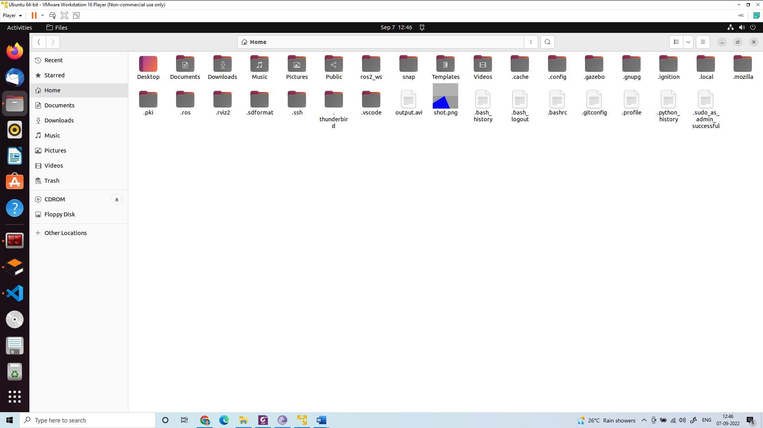
create a file extract_road.py inside the lab 6 folder

import cv2
import numpy

image = cv2.imread('/home/asha/shot.png')

def mouse(event,x,y,flags,param):
if event==cv2.EVENT_LBUTTONDOWN:
h=image[y,x,0]
s=image[y,x,1]
v=image[y,x,2]
print("H:",h)
print("S:",s)
print("V:",v)

cv2.namedWindow('mouse')
cv2.setMouseCallback('mouse',mouse)

cv2.imshow("original image", image)
cv2.imshow("mouse", image)
cv2.waitKey(0)
cv2.destroyAllWindows()

light_line = numpy.array([250,0,0])
dark_line = numpy.array([255,10,10])
mask = cv2.inRange(image, light_line,dark_line)
cv2.imshow('mask', mask)
cv2.waitKey(0)
cv2.destroyAllWindows()

canny= cv2.Canny(mask,30,5)
cv2.imshow('edge', canny)
cv2.waitKey(0)
cv2.destroyAllWindows()
print(canny.shape)

r1=200;c1=0
img = canny[r1:r1+200,c1:c1+512]
cv2.imshow('crop', img)
cv2.waitKey(0)
cv2.destroyAllWindows()

edge=[]
row =150

for i in range (512):
if(img[row,i]==255):
edge.append(i)
print(edge)

if(len(edge)==4):
left_edge=edge[0]
right_edge=edge[2]
print(edge)
if(len(edge)==3):
if(edge[1]-edge[0] > 5):
left_edge=edge[0]
right_edge=edge[1]
else:
left_edge=edge[0]
right_edge=edge[2]

road_width=(right_edge-left_edge)
frame_mid = left_edge + (road_width/2)
mid_point = 512/2
img[row,int(mid_point)]=255
print(mid_point)
error=mid_point-frame_mid

if(error < 0):
action="Go Right"
else :
action="Go Left"

print("error", error)

img[row,int(frame_mid)]=255
print("mid point of the frame", frame_mid)

f_image = cv2.putText(img, action, (50,50), cv2.FONT_HERSHEY_SIMPLEX, 1, (255,0,0), 1, cv2.LINE_AA)
cv2.imshow('final image',f_image)
cv2.waitKey(0)
cv2.destroyAllWindows()

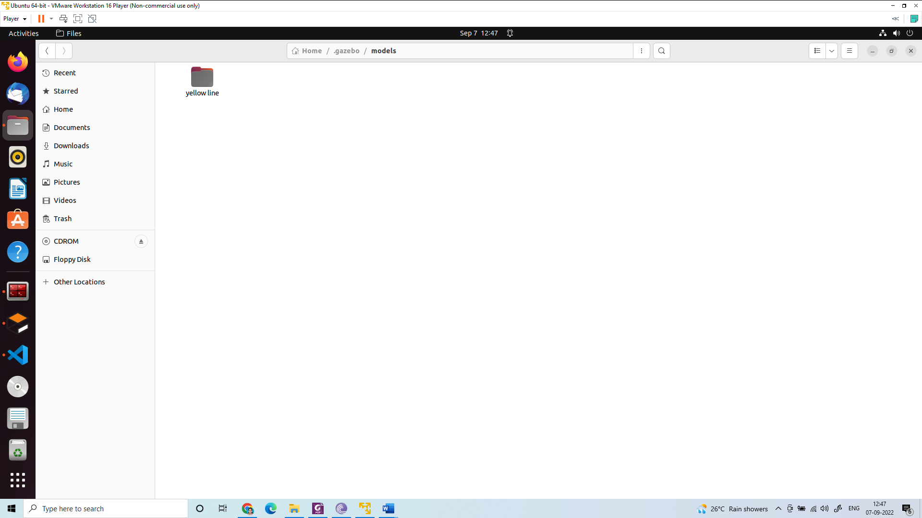

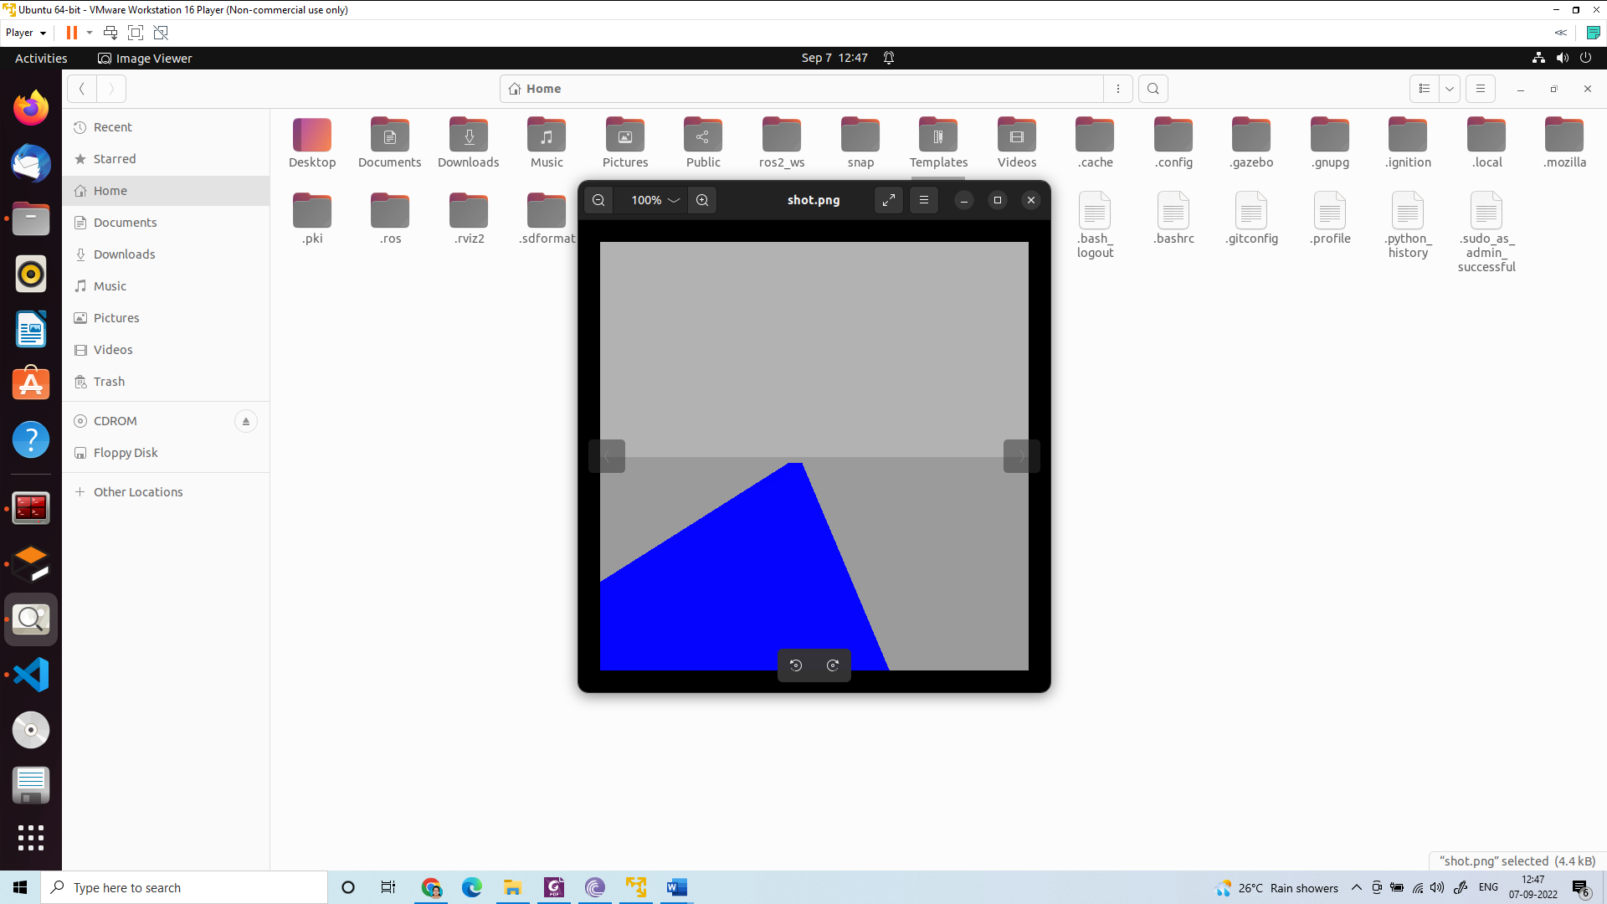

Create a line_follow.py inside the folder lab
import numpy
import rclpy
from rclpy.node import Node
from cv_bridge import CvBridge
from sensor_msgs.msg import Image
from geometry_msgs.msg import Twist

class LineFollower(Node):
def __init__(self\ super().__init__('line_follower')
self.bridge = CvBridge()
self.subscriber = self.create_subscription(Image,'/camera1/image_raw',self.process_data, 10)
self.publisher = self.create_publisher(Twist, '/cmd_vel', 40)
timer_period = 0.2
self.timer = self.create_timer(timer_period, self.send_cmd_vel)
self.velocity=Twist()
self.empty = False
self.error = 0
self.action=""
self.get_logger().info("Node Started!")

def send_cmd_vel(self):

if(self.empty):
self.velocity.linear.x=0.0
self.velocity.angular.z= 0.0
self.action="Stop"

else:
if(self.error > 0):
self.velocity.linear.x=0.1
self.velocity.angular.z=0.1
self.action="Go Left"
elif(self.error < 0):
self.velocity.linear.x=0.1
self.velocity.angular.z=-0.1
self.action="Go Right"
elif(self.error==0):
self.velocity.linear.x=0.1
self.velocity.angular.z= 0.0
self.action="Go Straight"

self.publisher.publish(self.velocity)

## Subscriber Call Back

def process_data(self, data):
self.get_logger().info("Image Received!")
frame = self.bridge.imgmsg_to_cv2(data)
light_line = numpy.array([250,0,0])
dark_line = numpy.array([255,10,10])
mask = cv2.inRange(frame, light_line,dark_line)
cv2.imshow('mask', mask)

canny= cv2.Canny(mask,30,5)
cv2.imshow('edge', canny)

r1=200;c1=0
img = canny[r1:r1+200,c1:c1+512]
cv2.imshow('crop', img)

edge=[]
row =150

for i in range(512):
if(img[row,i]==255):
edge.append(i)
print(edge)

if(len(edge)==0):
left_edge=512//2
right_edge=512//2
self.empty = True

if(len(edge)==1):
if edge[0]>512//2:
left_edge=0
right_edge=edge[0]
self.empty = False
else:
left_edge=edge[0]
right_edge=512
self.empty = False

if(len(edge)==2):
left_edge=edge[0]
right_edge=edge[1]
self.empty = False

if(len(edge)==3):
if(edge[1]-edge[0]>5):
left_edge=edge[0]
right_edge=edge[1]
self.empty = False
else:
left_edge=edge[0]
right_edge=edge[2]
self.empty = False

if(len(edge)==4):
left_edge=edge[0]
right_edge=edge[2]
self.empty = False

if(len(edge)>=5):
left_edge=edge[0]
right_edge=edge[len(edge)-1]
self.empty = False

road_width=(right_edge-left_edge)
frame_mid = left_edge + (road_width/2)
mid_point = 512/2
img[row,int(mid_point)]=255
print(mid_point)
self.error=mid_point-frame_mid
img[row,int(frame_mid)]=255
print(self.action)
f_image = cv2.putText(img, self.action, (100,100), cv2.FONT_HERSHEY_SIMPLEX, 1, (255,0,), 2, cv2.LINE_AA)

def main(args=None):
rclpy.init(args=args)
node = LineFollower()
rclpy.spin(node)
rclpy.shutdown()

if __name__ == '__main__':
main()

edit setup.py file

from setuptools import setup
import os
from glob import glob

package_name = 'lab6'

setup(
name=package_name,
version='0.0.0',
packages=[package_name],
data_files=[
('share/ament_index/resource_index/packages',
['resource/' + package_name]),
('share/' + package_name, ['package.xml']),
(os.path.join('share', package_name), glob('launch/*')),
(os.path.join('share', package_name), glob('urdf/*'))
],
install_requires=['setuptools'],
zip_safe=True,
maintainer='asha',
maintainer_email='asha.cs12@gmail.com',
description='TODO: Package description',
license='TODO: License declaration',
tests_require=['pytest'],
entry_points={
'console_scripts': [
'capture = lab6.capture_image:main',
'line = lab6.line_follow:main'
],
},
)
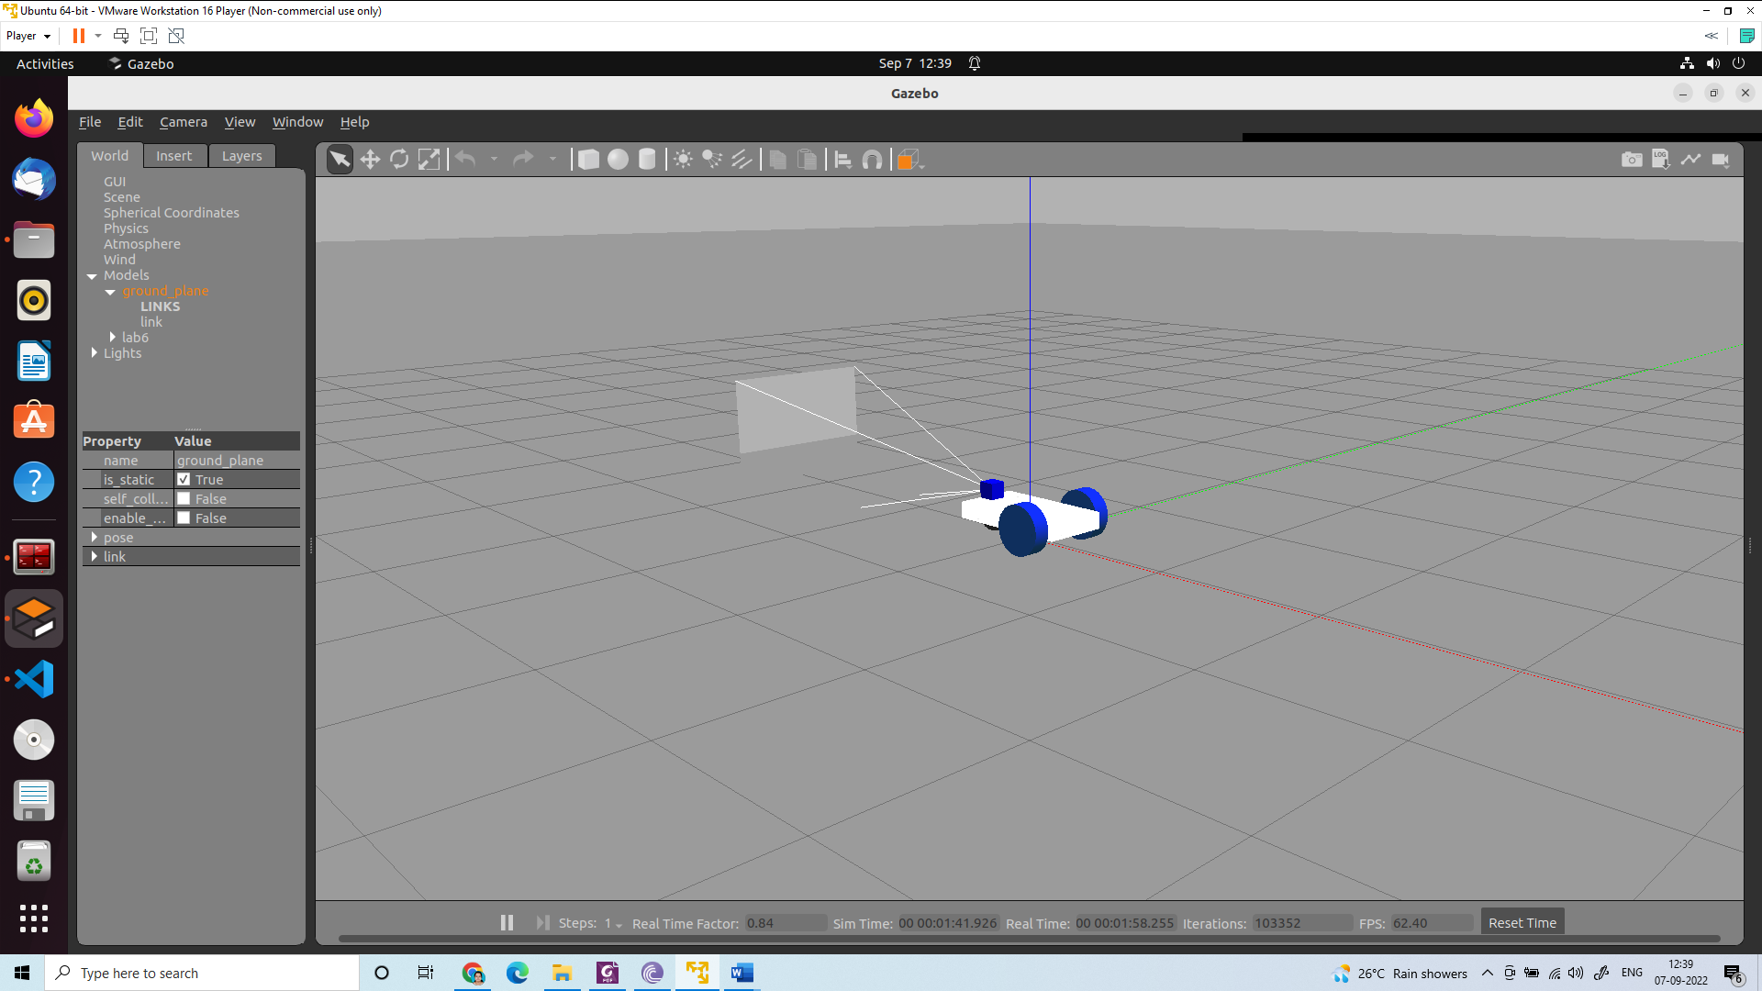

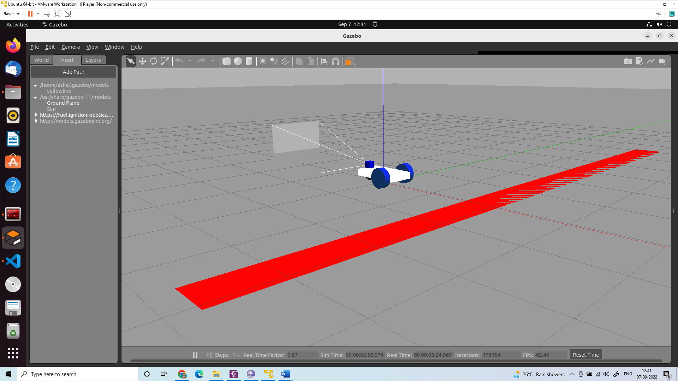
select yellow line

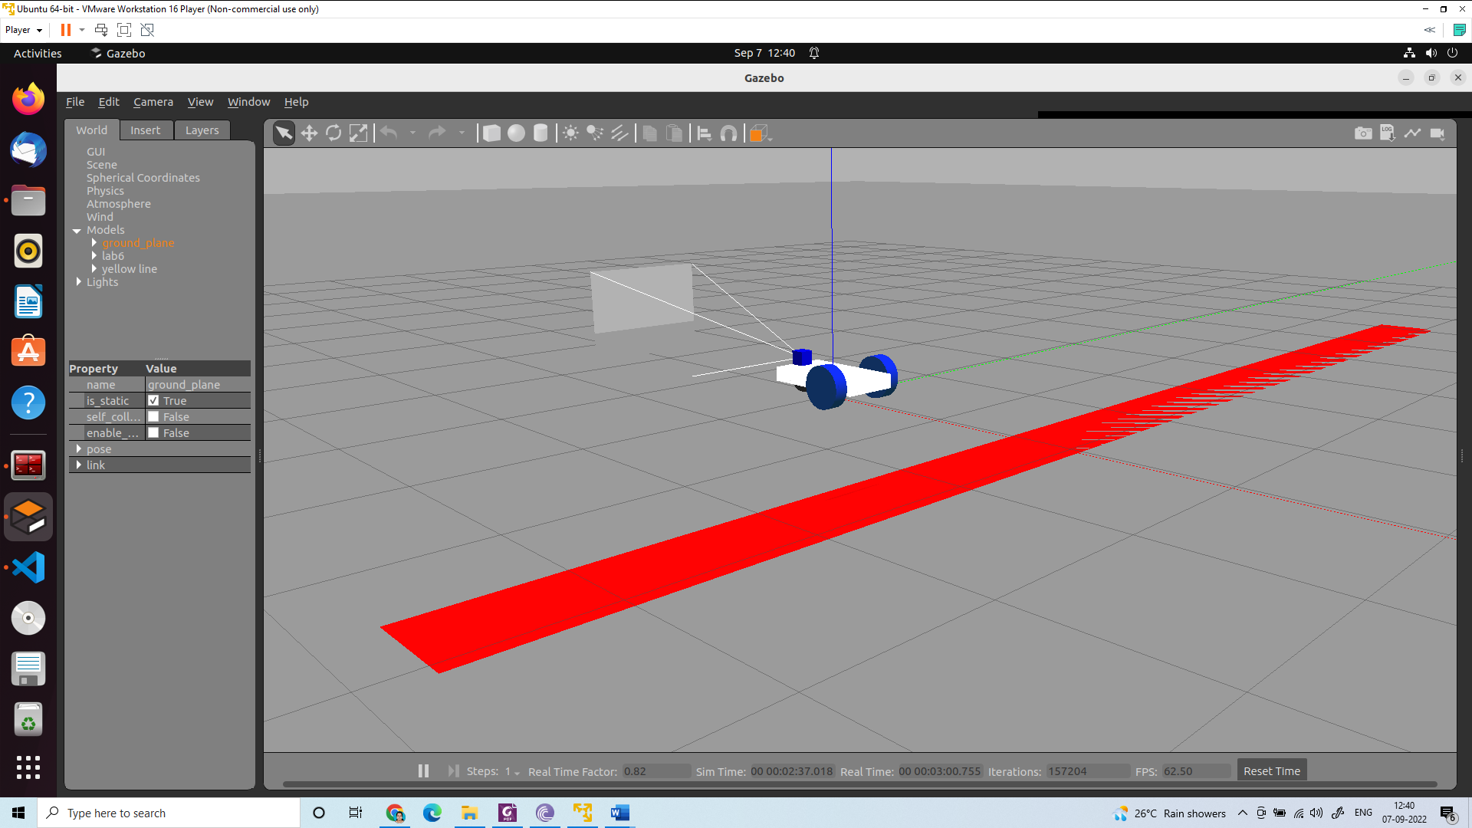
Use these to change the location and orientation of the robot

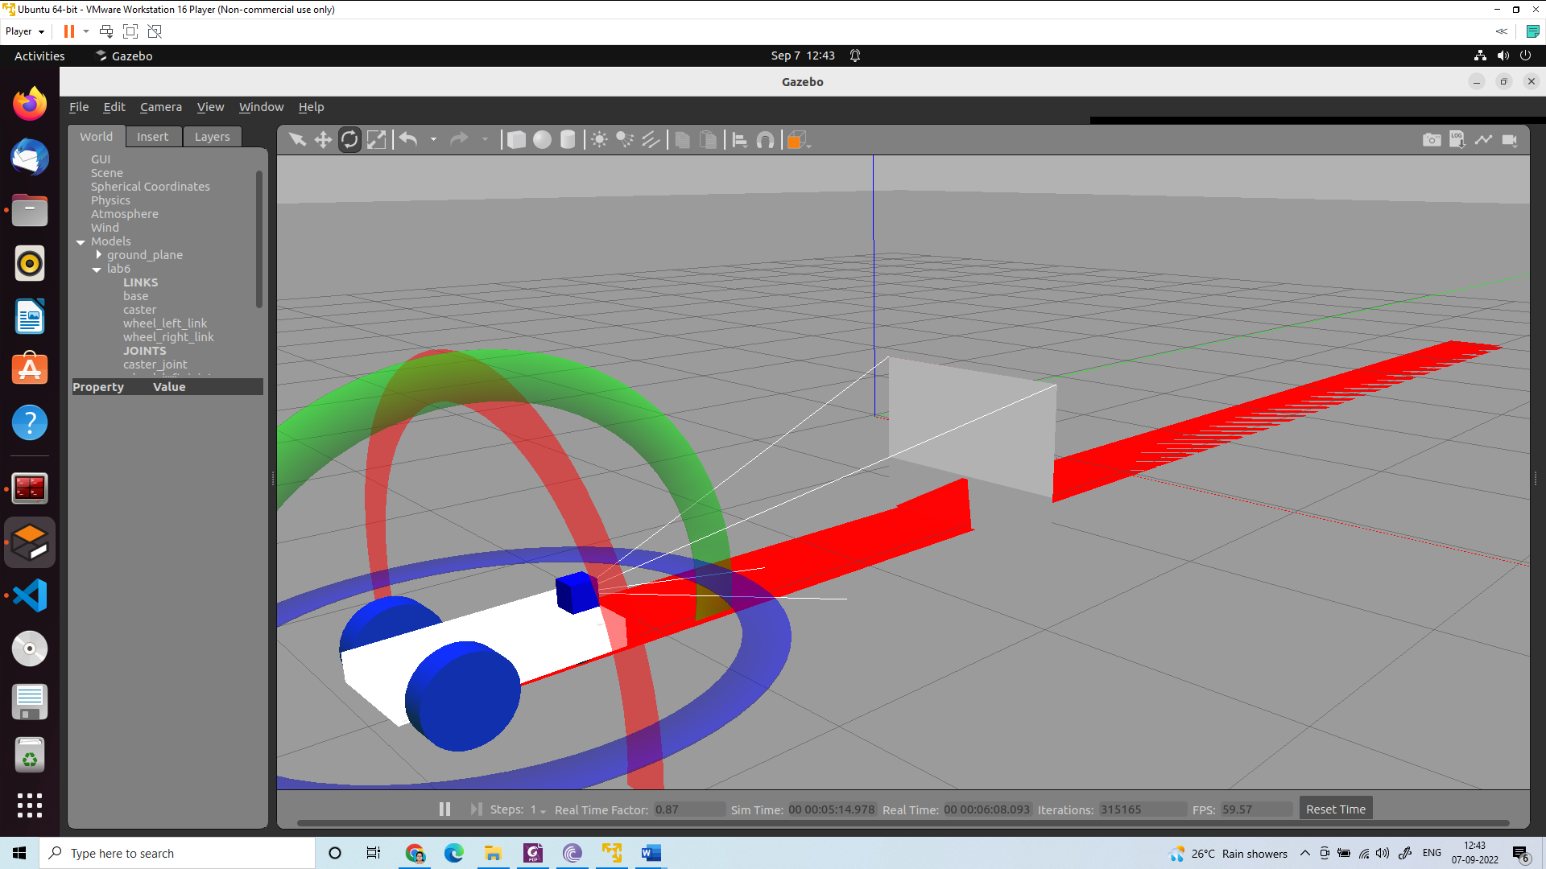

Terminal 1:
ros2 launch lab6 gazebo.launch.py

Terminal 2:
ros2 topic list

Terminal 3:
ros2 run lab6 line

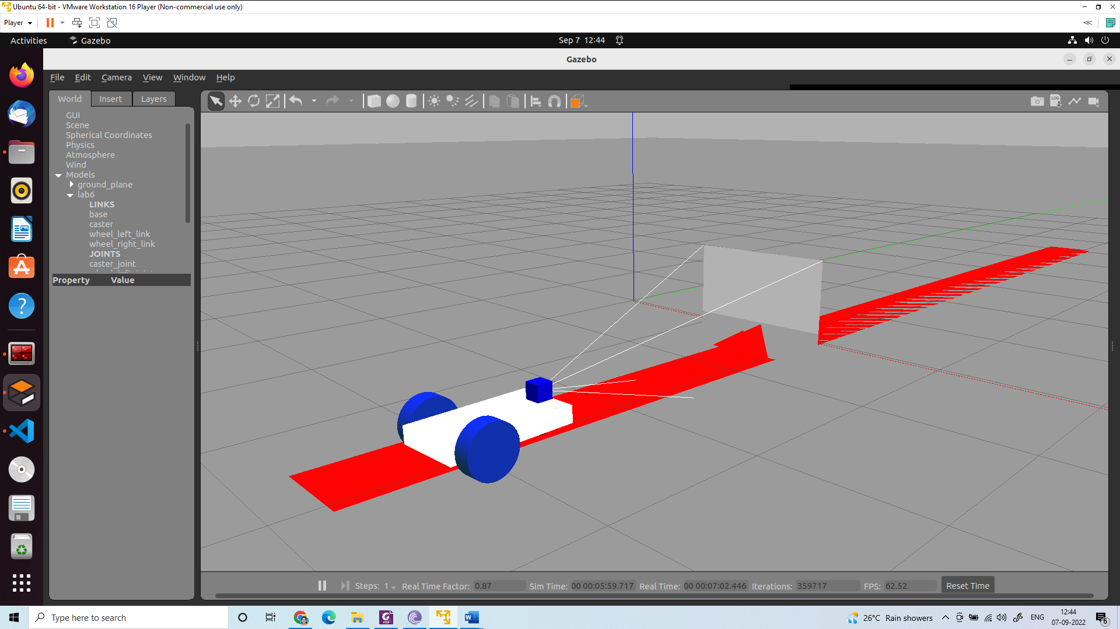

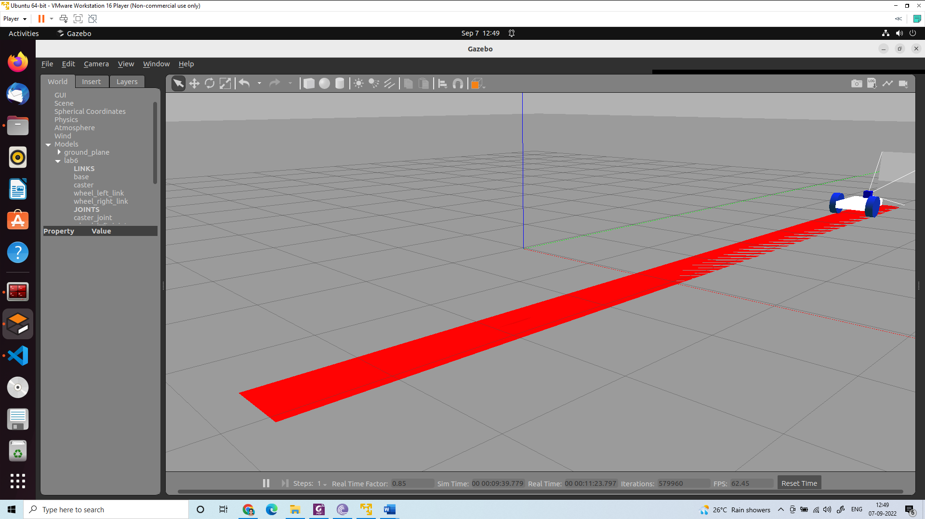

Create a red line

Create a world folder
Create a yellow line folder
Supplementary material:

Create a model.config

<?xml version="1.0" ?>
<model>
<name>yellowline</name>
<version>1.0</version>
<sdf version="1.6">model.sdf</sdf>
<author>
<name></name>
<email></email>
</author>
<description></description>
</model>

Create a model.sdf

<?xml version="1.0"?>
<sdf version="1.6">
<model name="yellow line">
<static>true</static>
<link name="link_ground">
<collision name="collision">
<geometry>
<plane>
<normal>0 0 1</normal>
<size>0.1 3.2</size>
</plane>
</geometry>

<surface>
<friction>
<ode>
<mu>100</mu>
<mu2>50</mu2>
</ode>
</friction>
</surface>
</collision>
<visual name="visual_ground">
<cast_shadows>false</cast_shadows>
<geometry>
<plane>
<normal>0 0 1</normal>
<size>0.5 10</size>
</plane>
</geometry>
<material>
<script>
<uri>file://media/materials/scripts/gazebo.material</uri>
<name>Gazebo/Red</name>
</script>
</material>
</visual>
</link>
</model>
</sdf>

Copy the folder into /home/asha/.gazebo/models/
In the gazebo window (gazebo)
Insert→/home/asha/.gazebo/models/→yellow line→all files
close gazebo (killall 9 gzserver) and open again (gazebo)

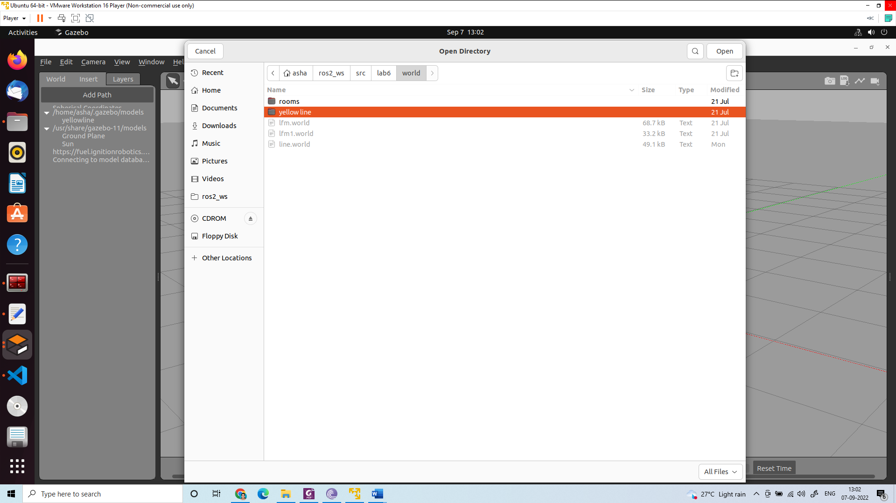

Insert→/home/asha/.gazebo/models/→yellow line

Exercise: Write a code to track the red ball in the gazebo simulation.

